

**SCHOOL OF COMPUTER SCIENCE ENGINEERING**

**AND INFORMATION SYSTEMS**

**WINTER SEMESTER 2024-2025**

**PMCA601P – FULL STACK WEB DEVELOPMENT LAB**

**CYCLESHEET – 2**

**SUBMITTED ON: 25 – JAN - 2025**

**SUBMITTED BY-**

**AKASH KUMAR BANIK**

**PROGRAM: MCA**

**REGISTER No.: 24MCA0242**

**CYCLESHEET 2 – Based on JAVASCRIPT**

**1. Design a web page which display digital clock as shown below. Also Create a web page containing three divisions.**

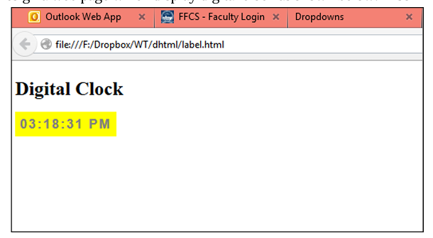

**a) The first division displays a digital clock on the rightmost end.**

**b) The width of the first division is 100%. The second division and third division lay side by side.**

**c) The second division has an image slider and third division has a color picker and two list box having font-family and size and a button. When a button is clicked the background color, font and font size should change for a whole page. Use JavaScript to implement the above.**

**CODE:**

<!DOCTYPE html>

<html lang="en">

<head>

<meta charset="UTF-8">

<meta name="viewport" content="width=device-width, initial-scale=1.0">

<title>Digital Clock</title>

<style>

body {

font-family: Arial, sans-serif;

margin: 0;

padding: 0;

display: flex;

flex-direction: column;

height: 100vh;

}

.header {

width: 100%;

display: flex;

justify-content: center;

padding: 10px;

background-color: #f4f4f4;

box-shadow: 0 0 10px rgba(0, 0, 0, 0.1);

}

.clock {

background-color: yellow;

padding: 5px;

font-size: 24px;

font-weight: bold;

}

.content {

display: flex;

width: 100%;

height: calc(100% - 60px);

}

.outer-container {

position: relative;

width: 70%;

overflow: hidden;

display: flex;

justify-content: center;

align-items: center;

background-color: #fff;

border: 1px solid #ccc;

box-shadow: 0 0 10px rgba(0, 0, 0, 0.1);

height: 100%;

}

.slider-container {

width: 80%;

height: 80%;

display: flex;

justify-content: center;

align-items: center;

background-color: #fff;

border: 1px solid #ccc;

box-shadow: 0 0 10px rgba(0, 0, 0, 0.1);

}

.slider-images {

display: flex;

transition: transform 0.5s ease;

justify-content: center;

align-items: center;

height: 100%;

}

.slider-images img {

max-width: 100%;

max-height: 100%;

display: none;

}

.slider-images img.active {

display: block;

}

.prev, .next {

position: absolute;

top: 50%;

padding: 5px;

background-color: rgba(0, 0, 0, 0.5);

color: white;

border: none;

cursor: pointer;

font-size: 18px;

transform: translateY(-50%);

width: 35px;

}

.prev {

left: 0;

}

.next {

right: 0;

}

.controls {

width: 30%;

padding: 20px;

background-color: #e0e0e0;

box-shadow: 0 0 10px rgba(0, 0, 0, 0.1);

height: 100%;

overflow-y: auto;

}

label {

display: block;

margin-top: 10px;

}

select, input {

width: 100%;

padding: 10px;

margin-top: 15px;

border: 1px solid #ccc;

border-radius: 5px;

}

input[type='color'] {

height: 40px;

}

button {

width: 100%;

padding: 10px;

margin: 20px 0;

background-color: #007bff;

color: white;

border: none;

border-radius: 5px;

cursor: pointer;

display: block;

}

button:hover {

background-color: #0056b3;

}

</style>

</head>

<body>

<div class="header">

<div class="clock" id="time"></div>

</div>

<div class="content">

<div class="outer-container" id="outerContainer">

<div class="slider-container">

<div class="slider-images" id="sliderImages">

<img src="https://hips.hearstapps.com/hmg-prod/images/2-spectre-unveiled-the-first-fully-electric-rolls-royce-front-3-4-1666037303.jpg?crop=0.845xw:1.00xh;0.0714xw,0&resize=980:*" class="active">

<img src="https://mclaren.scene7.com/is/image/mclaren/720S-Coupe_hero:crop-16x9?wid=1920&hei=1080">

<img src="http://m.gettywallpapers.com/wp-content/uploads/2023/01/BMW-Cars-Computer-Wallpaper.jpg">

<img src="http://m.gettywallpapers.com/wp-content/uploads/2023/01/BMW-Cars-Wallpaper-1920x1080-1.jpg">

</div>

<button class="prev" onclick="moveSlide(-1)">&#10094;</button>

<button class="next" onclick="moveSlide(1)">&#10095;</button>

</div>

</div>

<div class="controls">

<p>Pick a background color: <input type="color" id="bgcolor"></p>

<button onclick="changebg()">Change Background</button>

<br/>

<label>Pick the Font Style: </label>

<select id="fontselect" onchange="changefontstyle()">

<option value="Arial, sans-serif">Arial</option>

<option value="Verdana, Geneva, sans-serif">Verdana</option>

<option value="Times New Roman, Times, serif">Times New Roman</option>

<option value="Georgia, serif">Georgia</option>

<option value="Courier New, Courier, monospace">Courier New</option>

</select>

<br/>

<label>Pick the Font Size: </label>

<select id="sizeselect" onchange="changefontsize()">

<option value="18px">18px</option>

<option value="20px">20px</option>

<option value="24px">24px</option>

<option value="30px">30px</option>

<option value="36px">36px</option>

</select>

</div>

</div>

<script>

function clock(){

let currentTime= new Date();

let hours= currentTime.getHours();

let minutes= currentTime.getMinutes();

let seconds= currentTime.getSeconds();

const timer= hours + ' : ' + minutes + ' : ' + seconds + (hours > 11 ? ' PM' : ' AM');

document.getElementById('time').textContent= timer;

}

setInterval(clock,1000);

clock();

let currentIndex = 0;

function moveSlide(step) {

const images = document.querySelectorAll('.slider-images img');

const totalImages = images.length;

images[currentIndex].classList.remove('active');

currentIndex += step;

if (currentIndex < 0) {

currentIndex = totalImages - 1;

} else if (currentIndex >= totalImages) {

currentIndex = 0;

}

images[currentIndex].classList.add('active');

}

function changefontsize(){

var selectedsize= document.getElementById("sizeselect").value;

document.body.style.fontSize= selectedsize;

}

function changefontstyle(){

var selectedFont= document.getElementById("fontselect").value;

document.body.style.fontFamily= selectedFont;

}

function changebg(){

var color= document.getElementById("bgcolor").value;

document.getElementById("outerContainer").style.backgroundColor= color;

}

</script>

</body>

</html>

**OUTPUT:**

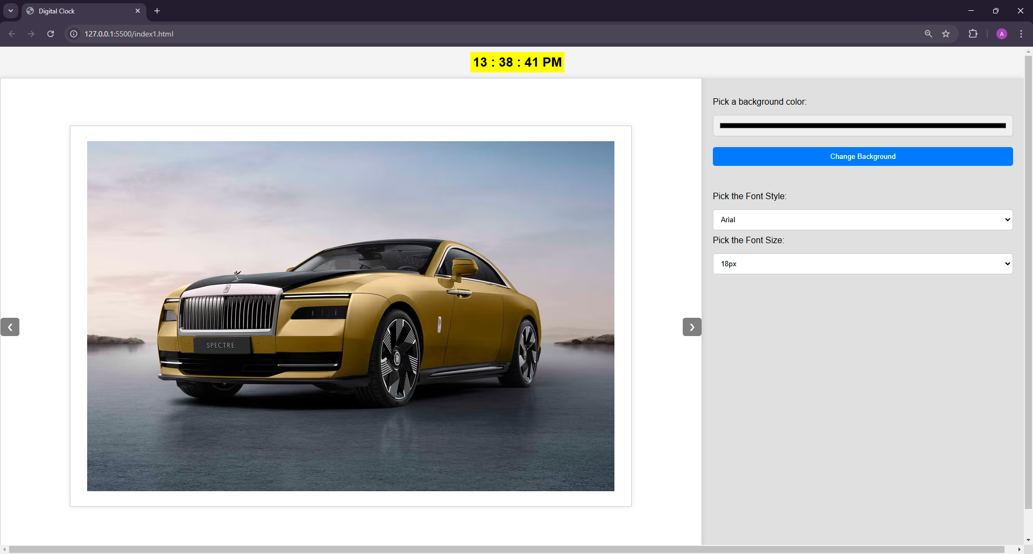

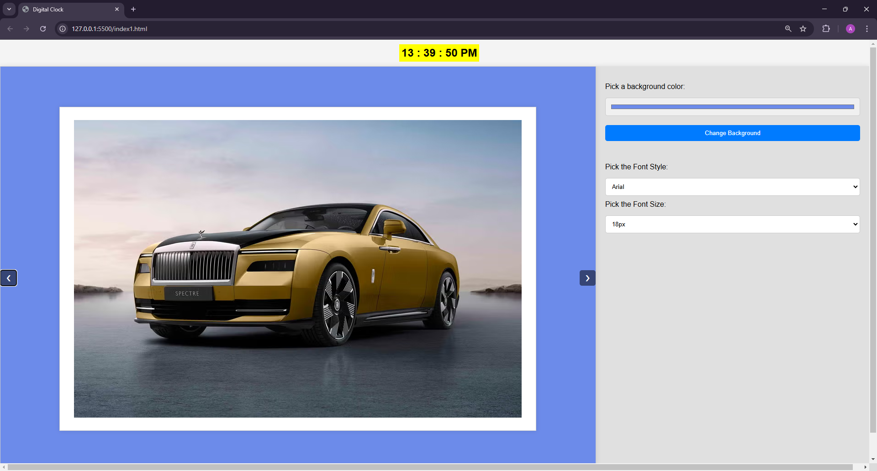

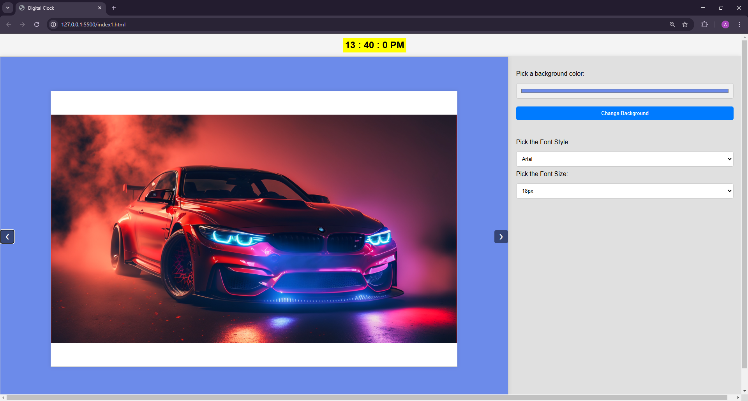

**2. Design form which contains text box and button. Once you click the button the message is displayed in the header tag, the text message whatever entered by the user in the textbox.**

**CODE:**

<!DOCTYPE html>

<html lang="en">

<head>

<meta charset="UTF-8">

<meta name="viewport" content="width=device-width, initial-scale=1.0">

<title>Message Display Form</title>

<style>

body{

background-color: rgb(208, 200, 253);

padding: 5px 0 0 30px;

font-size: large;

}

input{

width: 300px;

padding: 8px;

margin-left: 10px;

border-radius: 8px;

font-size: 1rem;

border-color: gray;

}

label{

font-size: 20px;

}

input:hover{

border-color: black;

}

button{

margin-left: 20px;

padding: 10px;

width: 150px;

border-radius: 8px;

color: #7b55e6;

font-weight: bold;

background-color: rgb(233, 245, 241);

}

button:hover{

background-color: rgb(105, 240, 105);

cursor: pointer;

}

</style>

<script>

function displayMessage() {

var message = document.getElementById("userTxt").value;

document.getElementById("header").innerText = message;

}

</script>

</head>

<body>

<h1 id="header">Your message will appear here</h1>

<form>

<label for="userTxt">Enter your message:</label>

<input type="text" id="userTxt" name="userTxt">

<button type="button" onclick="displayMessage()">Submit</button>

</form>

</body>

</html>

**OUTPUT:**

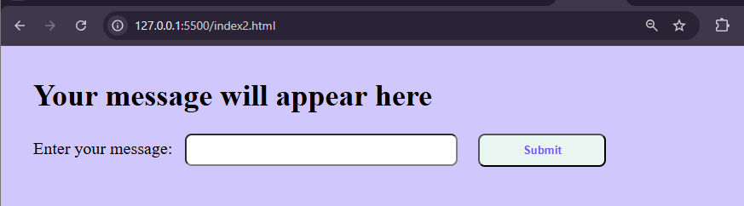

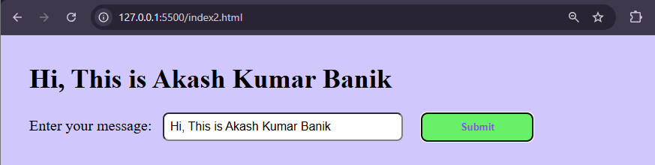

**3. Design a web page which contains three buttons with labelled as red, blue and green. On clicking the button the respective color should displayed as background color.**

**CODE:**

<!DOCTYPE html>

<html lang="en">

<head>

<meta charset="UTF-8">

<meta name="viewport" content="width=device-width, initial-scale=1.0">

<title>Document</title>

<style>

button{

width: 150px;

padding: 10px;

margin: 5px;

border-radius: 8px;

background-color: whitesmoke;

box-shadow: 3px 3px rgb(113, 91, 236);

}

button:hover{

background-color: bisque;

cursor: pointer;

}

</style>

</head>

<body>

<h2>Select the color for your background:</h2>

<button type="button" onclick="changeColor('red')">Red</button>

<button type="button" onclick="changeColor('blue')">Blue</button>

<button type="button" onclick="changeColor('green')">Green</button>

<script>

function changeColor(color){

document.bgColor=color;

}

</script>

</body>

</html>

**OUTPUT:**

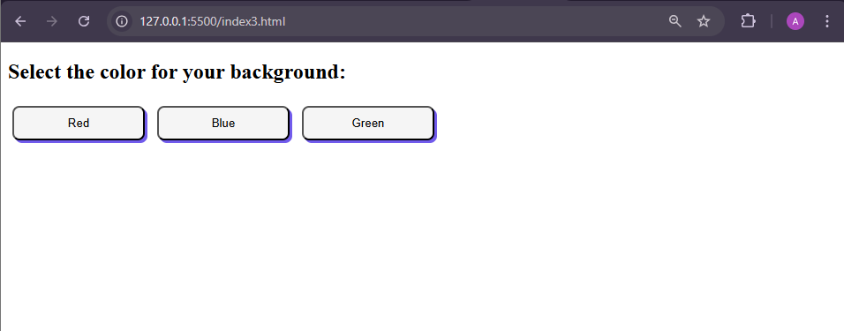

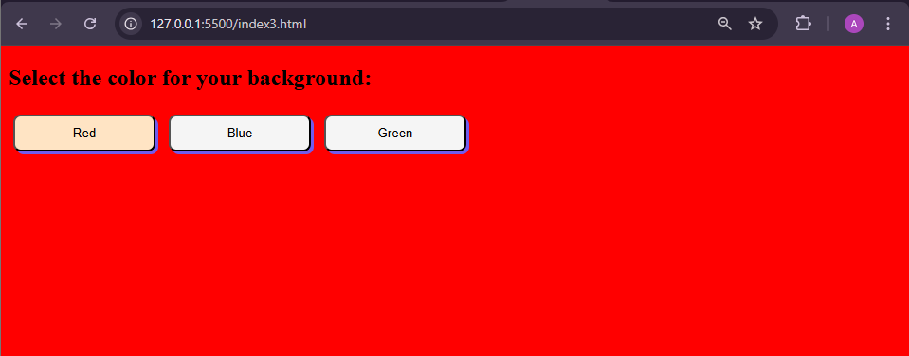

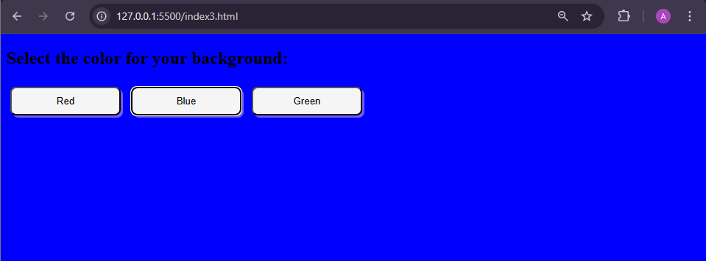

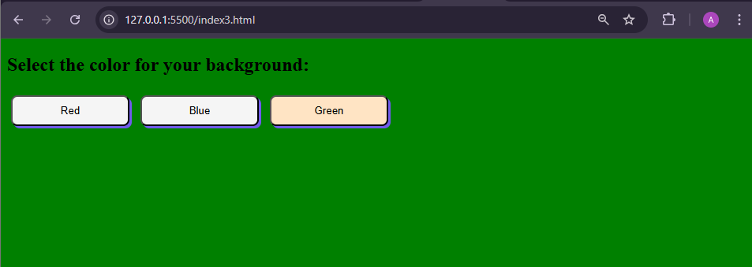

**4. Design a HTML page to generate an image slide show using Javascript. First input all the images(minimum of 5 images) you want to add to the slideshow. Add a button to start the slideshow. Repeatedly starting from the first to last, display each image for 5 seconds and then display the next image. Add two buttons to view the previous and next image.**

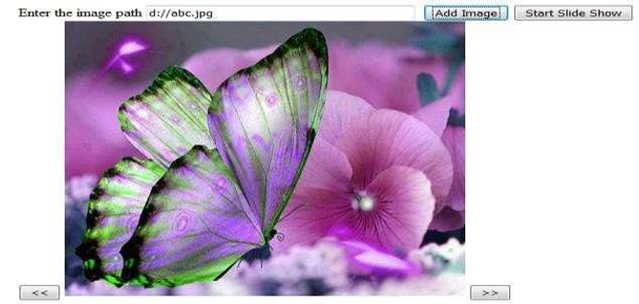

**CODE:**

<!DOCTYPE html>

<html lang="en">

<head>

<meta charset="UTF-8">

<meta name="viewport" content="width=device-width, initial-scale=1.0">

<title>Image Slideshow</title>

<style>

body {

background-color: beige;

}

.slider {

position: relative;

max-width: 550px;

margin: 20px auto;

overflow: hidden;

border: 1px solid black;

}

.slides {

display: flex;

transition: transform 0.5s ease-in-out;

width: 100%;

}

.slides img {

width: 100%;

flex: 1 0 100%;

}

.slidernav {

display: flex;

justify-content: center;

margin-top: 10px;

}

.slidernav button {

background-color: #333;

color: #fff;

border: none;

padding: 10px;

margin: 0 5px;

cursor: pointer;

}

.slidernav button:hover {

background-color: rgb(110, 110, 110);

cursor: pointer;

}

.slidernav button:disabled {

background-color: #555;

cursor: not-allowed;

}

.controls {

margin-top: 20px;

text-align: center;

}

.controls input {

margin: 10px 5px;

padding: 5px;

}

h1{

text-align: center;

color: darkblue;

}

input{

width: 300px;

padding: 10px;

margin-left: 10px;

border-radius: 8px;

font-size: 1rem;

border-color: gray;

}

button{

margin-left: 20px;

padding: 10px;

width: 150px;

border-radius: 8px;

color: darkblue;

font-weight: bold;

background-color: rgb(233, 245, 241);

}

button:hover{

background-color: rgb(87, 240, 87);

cursor: pointer;

}

.url-list {

max-width: 600px;

margin: 20px auto;

padding: 10px;

border: 1px solid #333;

background-color: #f9f9f9;

}

.url-list ul {

margin: 5px 0;

font-size: 0.9rem;

color: #555;

word-wrap: break-word;

}

</style>

</head>

<body>

<h1 style="text-align: center; color: darkblue;">Image Slider</h1>

<div class="slider">

<div class="slides">

<img src="images/happy-face2.png" alt="Image 1">

<img src="images/20.jpg" alt="Image 2">

<img src="images/21.jpg" alt="Image 3">

<img src="images/22.jpg" alt="Image 4">

<img src="images/31.jpg" alt="Image 5">

<img src="images/36.jpg" alt="Image 6">

</div>

</div>

<div class="slidernav">

<button onclick="prev()"><<</button>

<button onclick="next()">>></button>

</div>

<div class="controls">

<input type="text" id="imageURL" placeholder="Enter image URL">

<button onclick="addImage()">Add Image</button>

<button id="startBtn" onclick="startSlideShow()">Start Slide Show</button>

<button onclick="stopSlideShow()">Stop Slide Show</button>

</div>

<div class="url-list" id="urlList">

<h3 style="color: darkblue; text-align: center;">Added Image URLs</h3>

</div>

<script>

let currentIndex = 0;

const slides = document.querySelector('.slides');

let totalSlides = slides.children.length;

let slideShowInterval;

const startBtn = document.getElementById('startBtn');

const urlList = document.getElementById('urlList');

function showSlide(index) {

const offset = -index * 100;

slides.style.transform = `translateX(${offset}%)`;

}

function prev() {

currentIndex = (currentIndex - 1 + totalSlides) % totalSlides;

showSlide(currentIndex);

}

function next() {

currentIndex = (currentIndex + 1) % totalSlides;

showSlide(currentIndex);

}

function addImage() {

const imageURL = document.getElementById('imageURL').value;

if (imageURL) {

const img = document.createElement('img');

img.src = imageURL;

img.alt = `Image ${totalSlides + 1}`;

slides.appendChild(img);

totalSlides = slides.children.length;

document.getElementById('imageURL').value = '';

document.getElementById('imageURL').focus();

const urlElement = document.createElement('ul');

urlElement.textContent = imageURL;

urlList.appendChild(urlElement);

} else {

alert('Please enter a valid image URL.');

}

}

function startSlideShow() {

if (!slideShowInterval) {

slideShowInterval = setInterval(() => {

next();

}, 5000);

startBtn.disabled = true;

}

}

function stopSlideShow() {

clearInterval(slideShowInterval);

slideShowInterval = null;

startBtn.disabled = false;

}

</script>

</body>

</html>

**OUTPUT:**

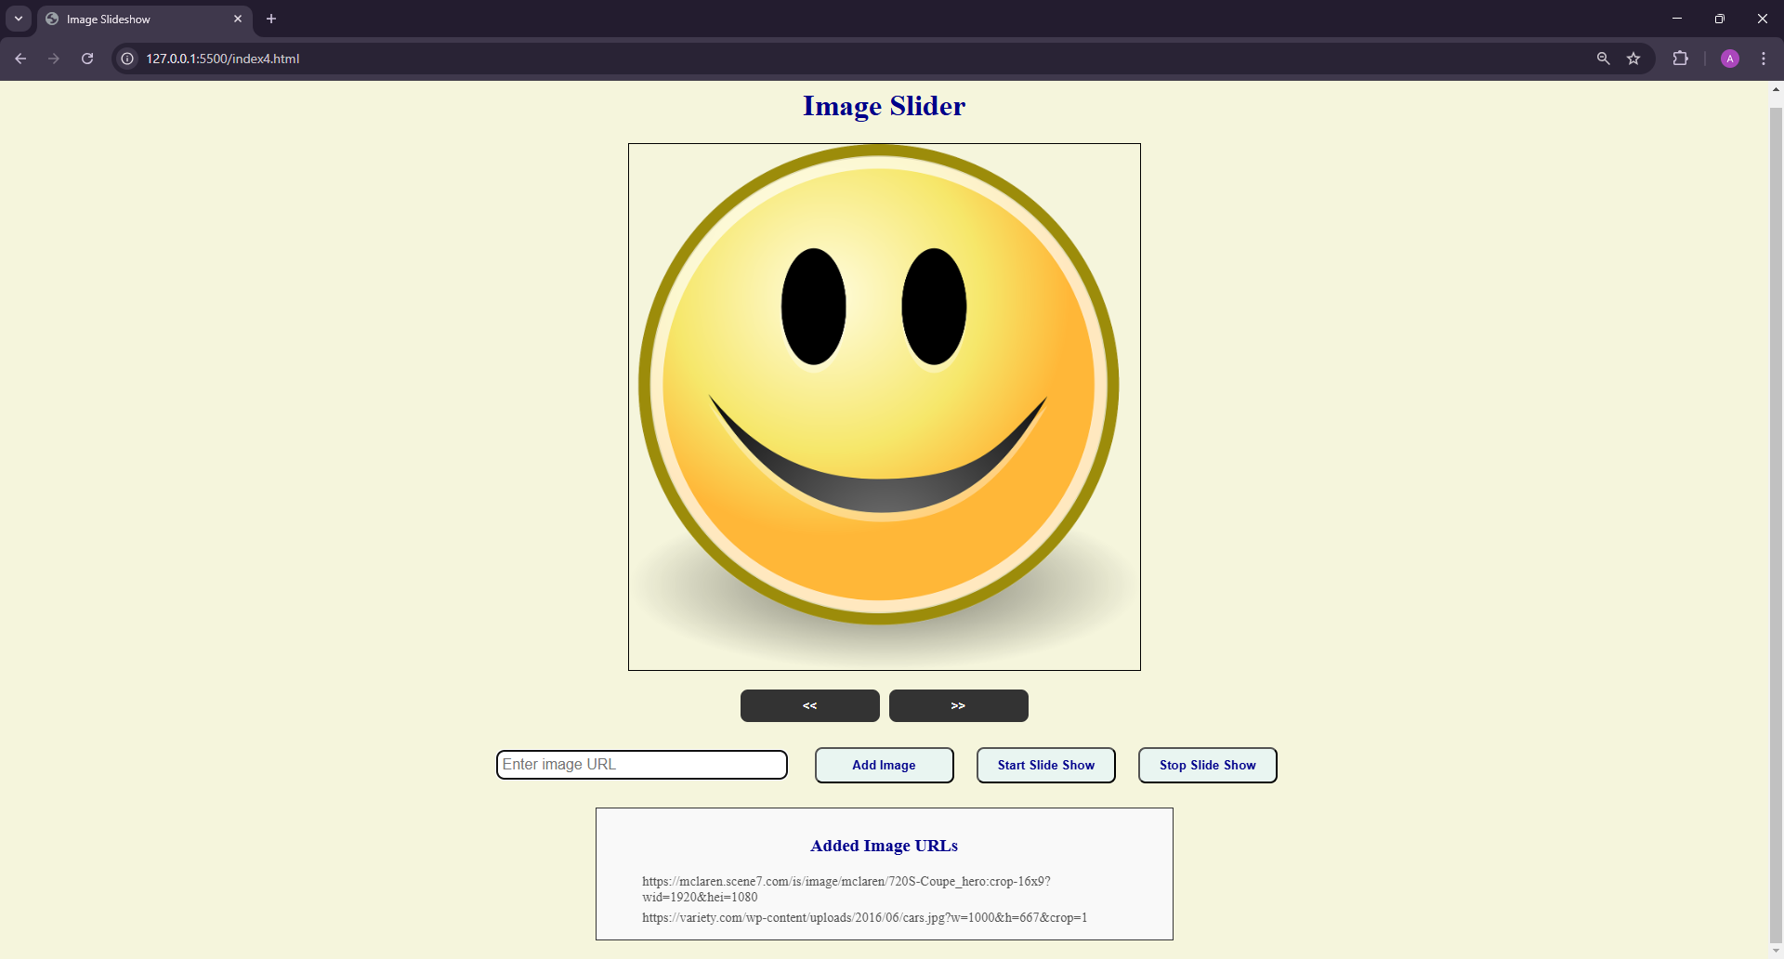

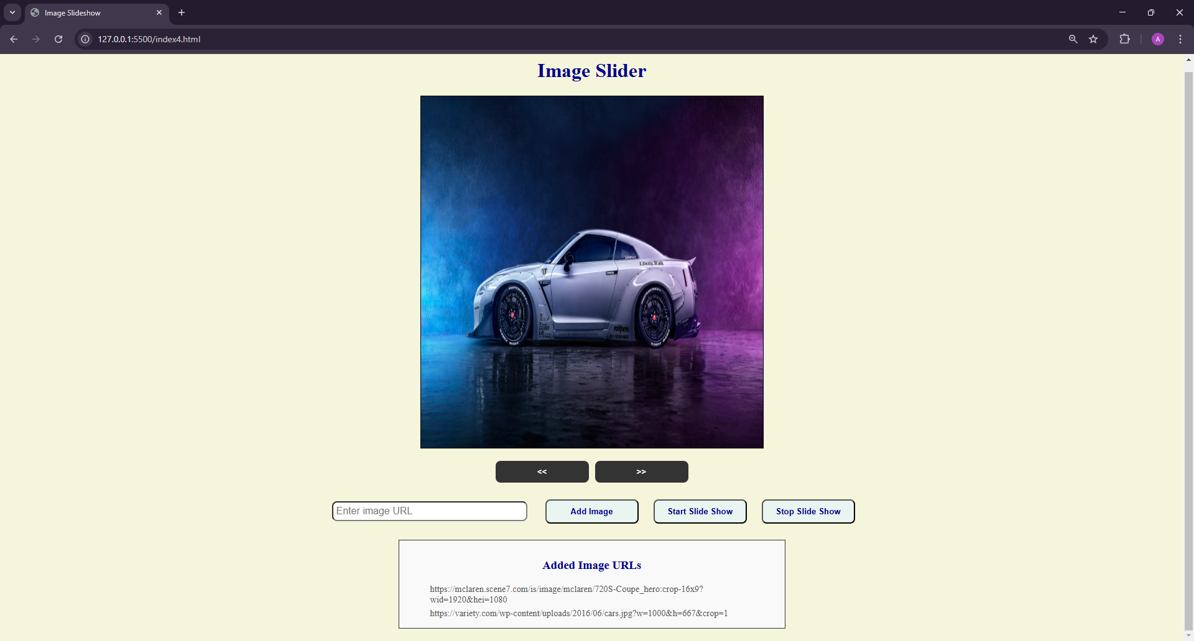

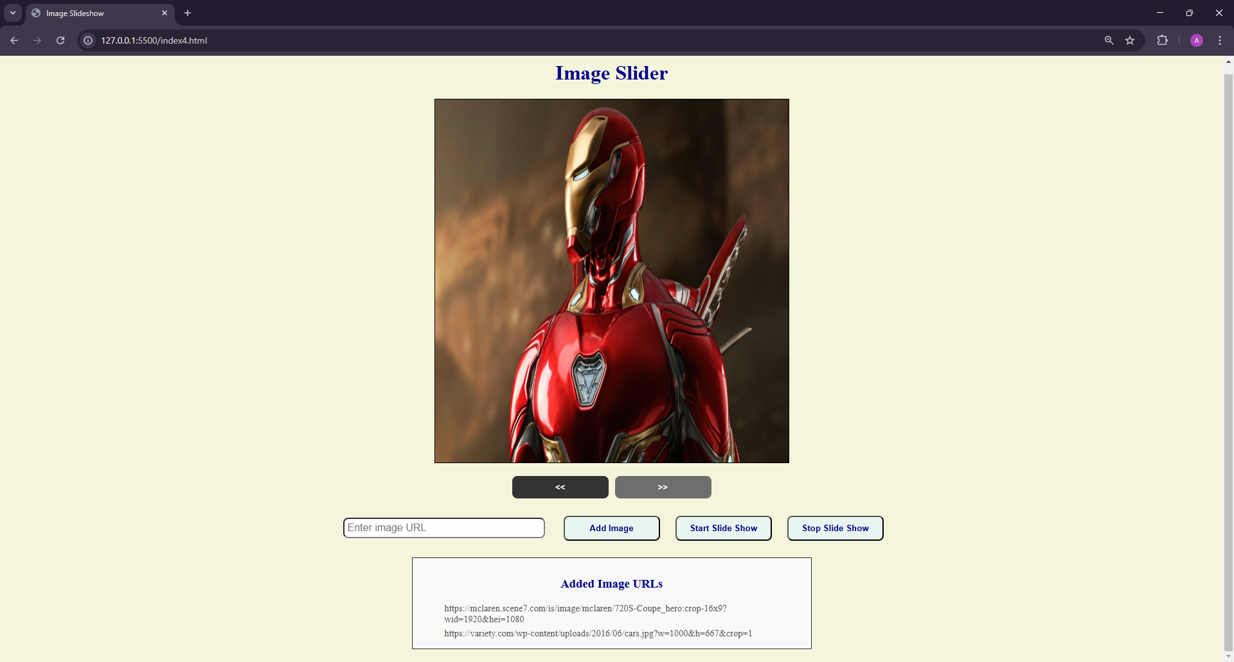

**5. Develop an Online Greetings Designer using Javascript and CSS. Add options to**

1. **change the image**
2. **Position the image (left, background, right)**
3. **Edit text**
4. **Change font size**
5. **Change font color**

**CODE:**

<!DOCTYPE html>

<html lang="en">

<head>

<meta charset="UTF-8">

<meta name="viewport" content="width=device-width, initial-scale=1.0">

<title>Online Greetings Designer</title>

<style>

body {

font-family: Arial, sans-serif;

margin: 0;

padding: 0;

display: flex;

height: 100vh;

background-color: #f4f4f4;

}

h1 {

color: darkblue;

}

.sidebar {

width: 30%;

padding: 20px;

background-color: #fff;

border-right: 1px solid #ccc;

box-shadow: 0 0 10px rgba(0, 0, 0, 0.1);

}

.main-content {

width: 70%;

padding: 20px;

display: flex;

align-items: center;

justify-content: center;

background-color: #fffcdc;

}

label {

display: block;

margin-top: 10px;

}

input, select {

width: 95%;

padding: 10px;

margin-top: 15px;

border: 1px solid #ccc;

border-radius: 5px;

}

select, input[type="color"]{

width: 100%;

}

button {

width: 60%;

padding: 10px;

margin: 20px auto;

background-color: #007bff;

color: white;

border: none;

border-radius: 5px;

cursor: pointer;

display: block;

}

button:hover {

background-color: #0056b3;

}

.greeting-card {

width: 100%;

height: 80%;

border: 1px solid #ccc;

background-color: white;

border-radius: 10px;

position: relative;

display: flex;

align-items: center;

justify-content: center;

background-size: cover;

background-position: center;

box-shadow: 0 0 20px rgba(0, 0, 0, 0.1);

}

.greeting-text {

position: absolute;

color: black;

font-size: 24px;

}

</style>

</head>

<body>

<div class="sidebar">

<h1><center>Online Greeting Designer</center></h1>

<label for="image-url">Image URL:</label>

<input type="text" id="image-url" placeholder="Enter image URL">

<label for="image-position">Image Position:</label>

<select id="image-position">

<option value="center">Background</option>

<option value="left">Left</option>

<option value="right">Right</option>

</select>

<label for="greeting-text">Greeting Text:</label>

<input type="text" id="greeting-text" placeholder="Enter greeting text">

<label for="font-size">Font Size:</label>

<input type="number" id="font-size" placeholder="Enter font size" min="10" max="100">

<label for="font-color">Font Color:</label>

<input type="color" id="font-color">

<label for="font-style">Font Style:</label>

<select id="font-style">

<option value="Arial">Arial</option>

<option value="Courier New">Courier New</option>

<option value="Georgia">Georgia</option>

<option value="Times New Roman">Times New Roman</option>

<option value="Verdana">Verdana</option>

</select>

<button type="button" onclick="updateGreetingCard()">Update Greeting Card</button>

</div>

<div class="main-content">

<div class="greeting-card" id="greeting-card">

<div class="greeting-text" id="greeting-text-display">Your Greeting Text Here</div>

</div>

</div>

<script>

function updateGreetingCard() {

const imageUrl = document.getElementById('image-url').value;

const imagePosition = document.getElementById('image-position').value;

const greetingText = document.getElementById('greeting-text').value;

const fontSize = document.getElementById('font-size').value;

const fontColor = document.getElementById('font-color').value;

const fontStyle = document.getElementById('font-style').value;

const greetingCard = document.getElementById('greeting-card');

const greetingTextDisplay = document.getElementById('greeting-text-display');

if (imageUrl) {

greetingCard.style.backgroundImage = `url(${imageUrl})`;

}

if (imagePosition === 'left') {

greetingCard.style.backgroundPosition = 'left';

} else if (imagePosition === 'right') {

greetingCard.style.backgroundPosition = 'right';

} else {

greetingCard.style.backgroundPosition = 'center';

}

greetingTextDisplay.textContent = greetingText;

greetingTextDisplay.style.fontSize = `${fontSize}px`;

greetingTextDisplay.style.color = fontColor;

greetingTextDisplay.style.fontFamily = fontStyle;

}

</script>

</body>

</html>

**OUTPUT:**

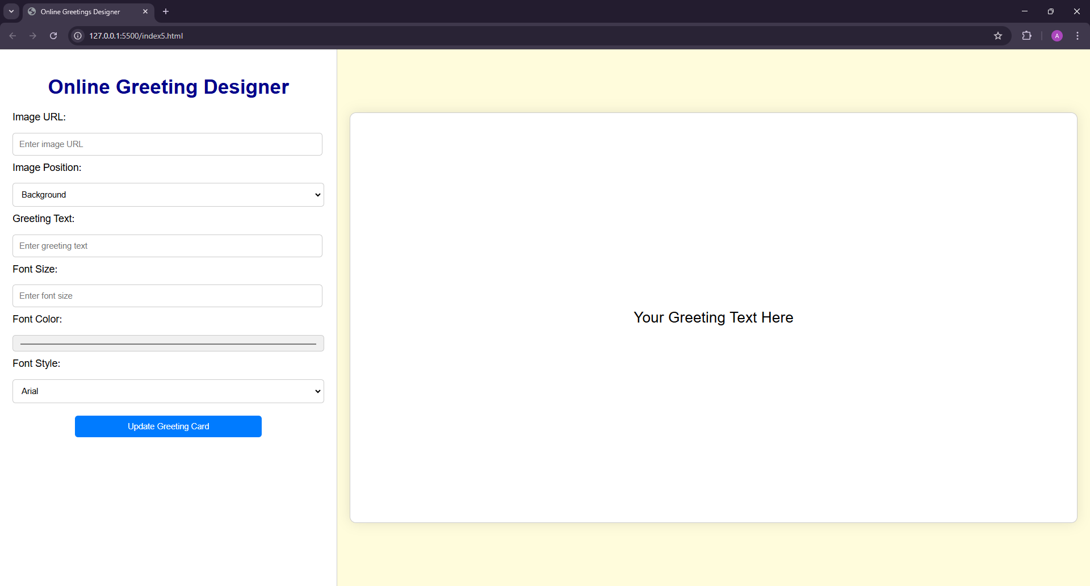

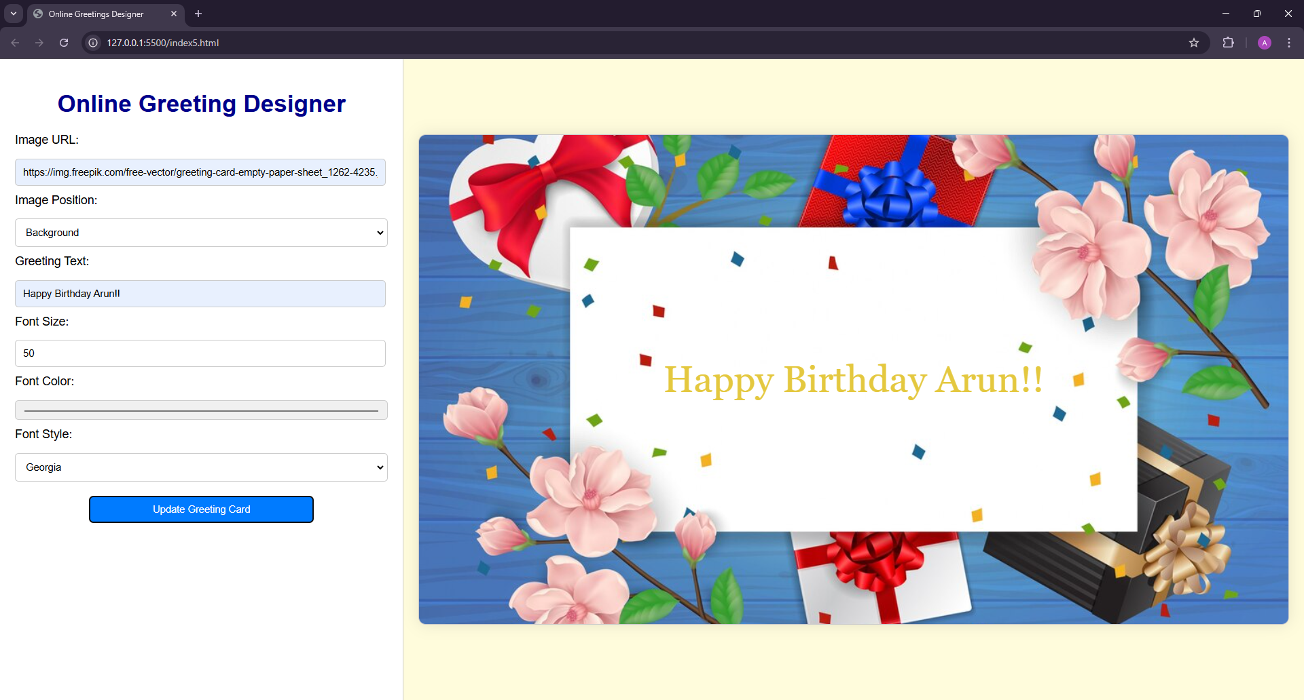

**6. Design an online Resume Generator using HTML and Javascript. Design a HTML page where the user can input his personal, academic and experience details. Using Javascript generate the formatted resume.**

**CODE:**

<!DOCTYPE html>

<html lang="en">

<head>

<meta charset="UTF-8">

<meta name="viewport" content="width=device-width, initial-scale=1.0">

<title>Online Resume Generator</title>

<style>

body {

font-family: Arial, sans-serif;

background-color: #f4f4f9;

margin: 0;

padding: 0;

display: flex;

justify-content: center;

align-items: center;

min-height: 100vh;

}

.container {

width: 90%;

max-width: 1200px;

background: #fff;

box-shadow: 0 4px 8px rgba(0, 0, 0, 0.1);

padding: 20px;

border-radius: 8px;

display: flex;

gap: 20px;

}

.form-section, .resume-section {

flex: 1;

padding: 10px;

}

h2 {

text-align: center;

color: #333;

}

label {

font-weight: bold;

margin-top: 10px;

display: block;

}

input, textarea {

width: 100%;

padding: 8px;

margin-top: 5px;

margin-bottom: 15px;

border: 1px solid #ccc;

border-radius: 5px;

box-sizing: border-box;

}

textarea {

resize: none;

}

button {

display: block;

width: 100%;

padding: 10px;

background-color: #007bff;

color: #fff;

border: none;

border-radius: 5px;

cursor: pointer;

font-size: 16px;

}

button:hover {

background-color: #0056b3;

}

.resume-section {

background: #f9f9f9;

border: 1px solid #ddd;

border-radius: 8px;

padding: 20px;

overflow-y: auto;

max-height: 880px;

}

.resume-section h3 {

color: #007bff;

}

.resume-section p {

margin: 5px 0;

line-height: 1.5;

}

</style>

</head>

<body>

<div class="container">

<div class="form-section">

<h2>Enter Your Details</h2>

<label for="name">Full Name:</label>

<input type="text" id="name" placeholder="Enter your full name">

<label for="email">Email:</label>

<input type="email" id="email" placeholder="Enter your email">

<label for="phone">Phone:</label>

<input type="tel" id="phone" placeholder="Enter your phone number">

<label for="education">Academic Details:</label>

<textarea id="education" rows="3" placeholder="Add your academic qualifications"></textarea>

<label for="certifications">Certifications:</label>

<textarea id="certifications" rows="3" placeholder="Add certifications (if any)"></textarea>

<label for="experience">Work Experience:</label>

<textarea id="experience" rows="3" placeholder="Add your work experience"></textarea>

<label for="skills">Skills:</label>

<textarea id="skills" rows="3" placeholder="List your skills"></textarea>

<label for="languages">Languages Known:</label>

<textarea id="languages" rows="3" placeholder="List the languages you know"></textarea>

<button onclick="generateResume()">Generate Resume</button>

</div>

<div class="resume-section" id="resume">

<h2>Formatted Resume</h2>

</div>

</div>

<script>

function generateResume() {

const name = document.getElementById('name').value.toUpperCase();

const email = document.getElementById('email').value;

const phone = document.getElementById('phone').value;

const education = document.getElementById('education').value;

const certifications = document.getElementById('certifications').value;

const experience = document.getElementById('experience').value;

const skills = document.getElementById('skills').value;

const languages = document.getElementById('languages').value;

if (!name || !email || !phone || !education || !experience || !skills) {

alert('Please fill out all required fields.');

return;

}

const resume = `

<h3>${name}</h3>

<p><strong>Email:</strong> ${email}</p>

<p><strong>Phone:</strong> ${phone}</p>

<hr>

<h3>Academic Details</h3>

<p>${education.replace(/\n/g, '<br>')}</p>

<hr>

<h3>Certifications</h3>

<p>${certifications.replace(/\n/g, '<br>')}</p>

<hr>

<h3>Work Experience</h3>

<p>${experience.replace(/\n/g, '<br>')}</p>

<hr>

<h3>Skills</h3>

<p>${skills.replace(/\n/g, '<br>')}</p>

<hr>

<h3>Languages Known</h3>

<p>${languages.replace(/\n/g, '<br>')}</p>

`;

document.getElementById('resume').innerHTML = resume;

}

</script>

</body>

</html>

**OUTPUT:**

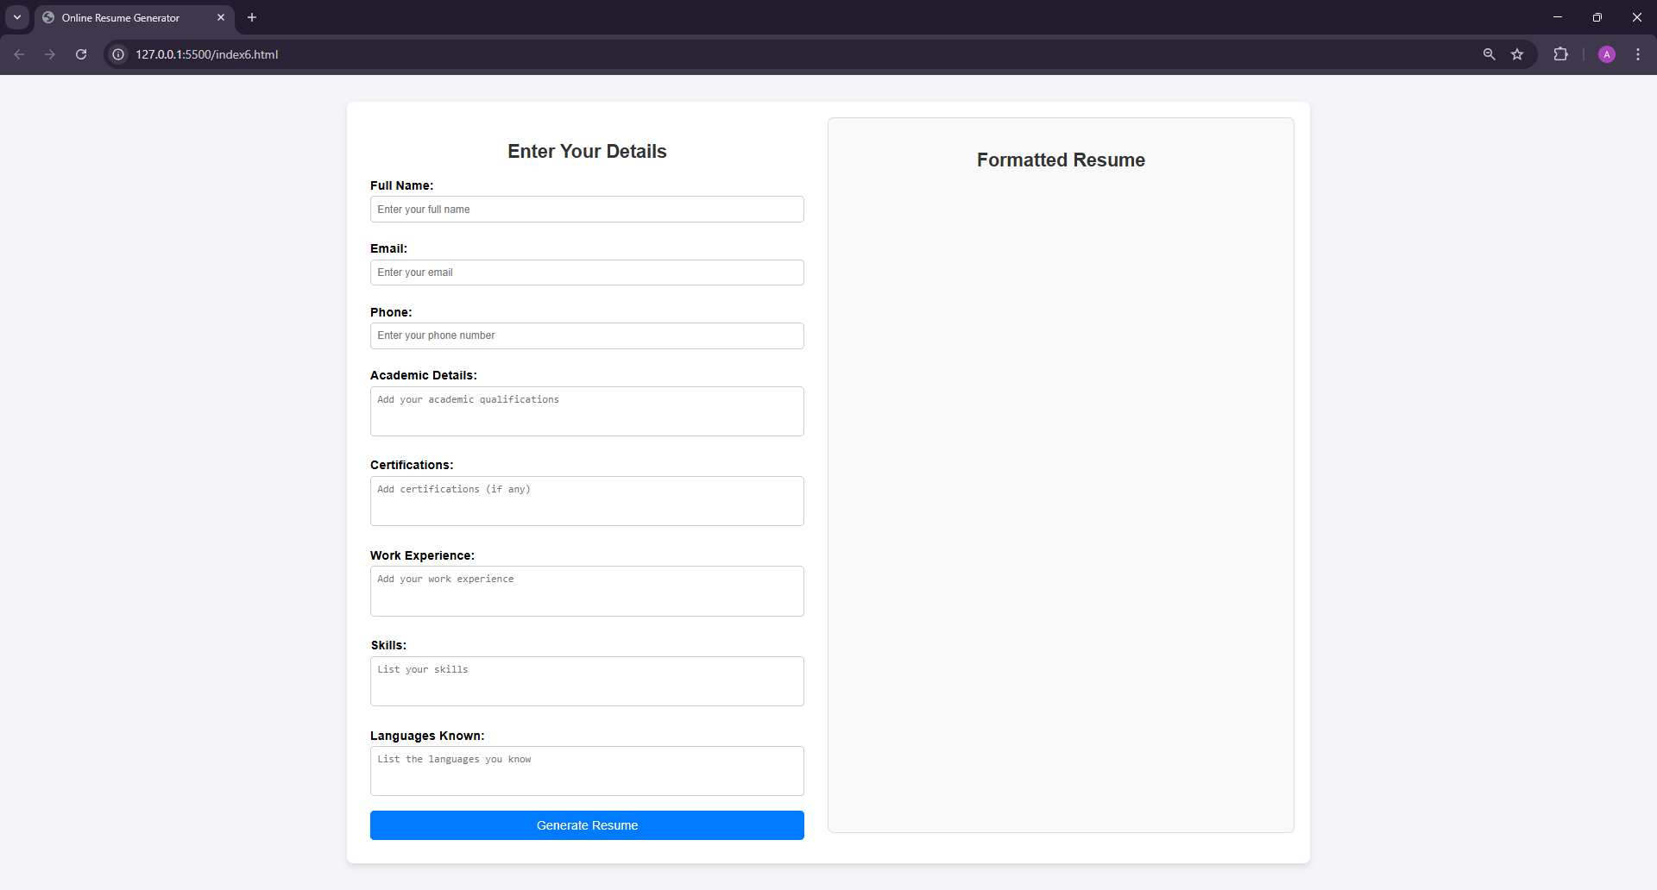

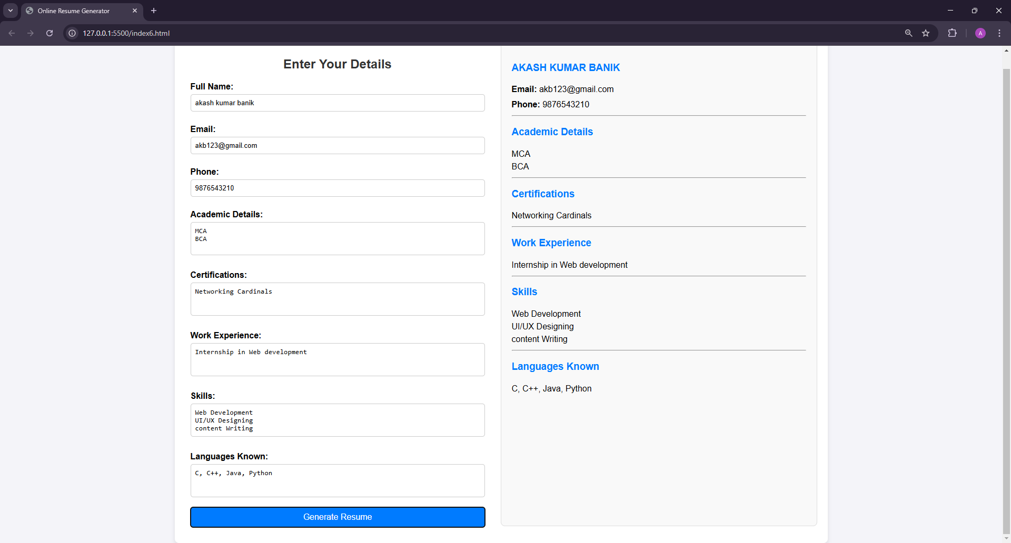

**7. A parking garage charges a $2.00 minimum fee to park for up to three hours. The garage charges an additional $0.50 per hour for each hour or part thereof in excess of three hours. The maximum charge for any given 24-hour period is $10.00. Assume that no car parks for longer than 24 hours at a time. Write a script that calculates and displays the parking charges for each customer who parked a car in this garage yesterday. You should input from the user the hours parked for each customer. The program should display the charge for the current customer and should calculate and display the running total of yesterday's receipts. The program should use the function calculate-Charges to determine the charge for each customer. Use a text input field to obtain the input from the user.**

**CODE:**

<!DOCTYPE html>

<html lang="en">

<head>

<meta charset="UTF-8">

<meta name="viewport" content="width=device-width, initial-scale=1.0">

<title>Parking Garage Charges</title>

<style>

body {

font-family: Arial, sans-serif;

margin: 0;

padding: 0;

display: flex;

flex-direction: column;

align-items: center;

height: 100vh;

background-color: #f4f4f4;

}

h1 {

text-align: center;

margin-top: 30px;

padding: 20px;

}

.container {

width: 600px;

padding: 20px;

background-color: #fff;

border-radius: 10px;

box-shadow: 0 0 10px rgba(0, 0, 0, 0.1);

}

label {

display: block;

margin-top: 10px;

}

input[type="number"] {

width: 95%;

padding: 10px;

margin-top: 15px;

border: 1px solid #ccc;

border-radius: 5px;

}

.button-container {

display: flex;

justify-content: center;

margin-top: 15px;

}

button {

width: 60%;

padding: 10px;

background-color: #007bff;

color: white;

border: none;

border-radius: 5px;

cursor: pointer;

}

button:hover {

background-color: #0056b3;

}

.output {

margin-top: 20px;

background-color: #f9f9f9;

padding: 10px;

border-radius: 5px;

border: 1px solid #ccc;

display: none;

}

.output p {

margin: 0;

}

</style>

</head>

<body>

<h1>Parking Garage Charges</h1>

<div class="container">

<label for="hours">Enter Hours Parked:</label>

<input type="number" id="hours" placeholder="Enter hours parked" min="0" step="0.1" required>

<div class="button-container">

<button type="button" onclick="processParkingCharge()">Calculate Charge</button>

</div>

<div class="output" id="output"></div>

</div>

<script>

let totalReceipts = 0;

let customerCount = 0;

function calculateCharges(hours) {

if (hours <= 3) {

return 2.0;

} else if (hours > 3 && hours <= 24) {

return Math.min(2.0 + 0.5 * Math.ceil(hours - 3), 10.0);

}

return 10.0;

}

function processParkingCharge() {

const hoursInput = document.getElementById('hours');

const hours = parseFloat(hoursInput.value);

const outputDiv = document.getElementById('output');

if (isNaN(hours) || hours <= 0 || hours > 24) {

alert('Please enter a valid number of hours (between 0 and 24).');

return;

}

customerCount++;

const charge = calculateCharges(hours);

totalReceipts += charge;

const currentOutput = `

<p><strong><center>Total Charges</center></strong></p>

<p><strong>Customer ${customerCount}:</strong></p>

<p>Hours Parked: ${hours.toFixed(2)}</p>

<p>Charge: $${charge.toFixed(2)}</p>

<hr>

<p><strong>Total Receipts:</strong> $${totalReceipts.toFixed(2)}</p>

`;

outputDiv.innerHTML = currentOutput;

outputDiv.style.display = 'block';

hoursInput.value = '';

}

</script>

</body>

</html>

**OUTPUT:**

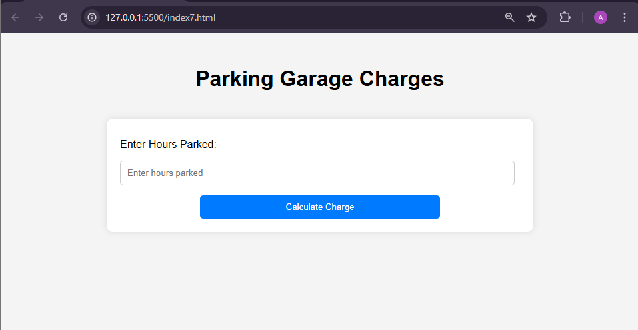

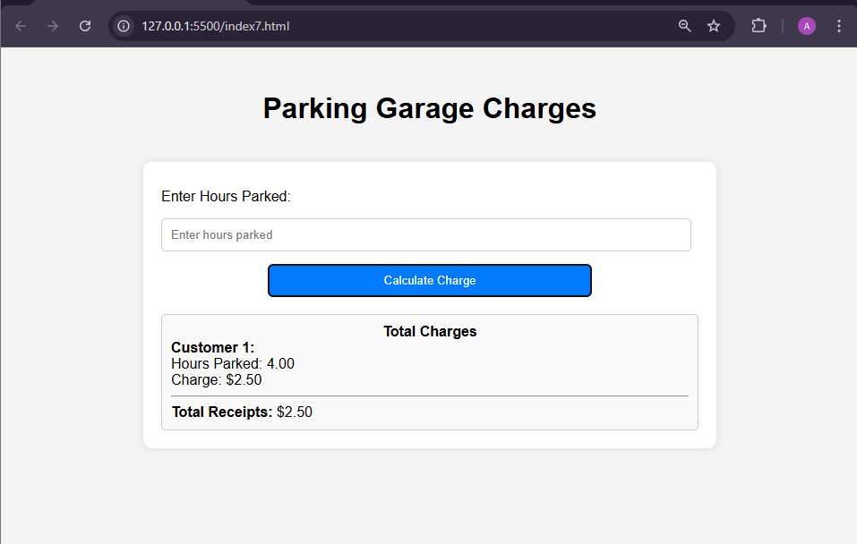

**8. Create a script that uses regular expressions to validate credit card numbers. Major credit card numbers must be in the following formats:**

* **American Express—Numbers start with 34 or 37 and consist of 15 digits.**
* **Diners Club—Numbers begin with 300 through 305, or 36 and 38 and consists of 14 digits.**
* **Discover—Numbers begin with 6011 or 65 and consist of 16 digits.**
* **JCB—Numbers beginning with 2131 or 1800 consist of 15 digits, while numbers beginning with 35 consist of 16 digits.**
* **MasterCard—Numbers start with the numbers 51 through 55 and consist of 16 digits.**
* **Visa—Numbers start with a 4; new cards consist of 16 digits and old cards consist of 13 digits.**

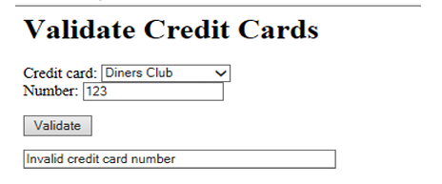

**CODE:**

<!DOCTYPE html>

<html lang="en">

<head>

<meta charset="UTF-8">

<meta name="viewport" content="width=device-width, initial-scale=1.0">

<title>Credit Card Validator</title>

<style>

body {

font-family: Arial, sans-serif;

margin: 0;

padding: 0;

display: flex;

flex-direction: column;

align-items: center;

height: 100vh;

background-color: #f4f4f4;

}

h1 {

text-align: center;

margin-top: 30px;

padding: 20px;

}

.container {

width: 600px;

padding: 20px;

background-color: #fff;

border-radius: 10px;

box-shadow: 0 0 10px rgba(0, 0, 0, 0.1);

text-align: center;

}

label {

display: block;

margin-top: 10px;

}

input[type="text"] {

width: 95%;

padding: 10px;

margin-top: 15px;

border: 1px solid #ccc;

border-radius: 5px;

}

button {

width: 60%;

padding: 10px;

margin-top: 15px;

background-color: #007bff;

color: white;

border: none;

border-radius: 5px;

cursor: pointer;

}

button:hover {

background-color: #0056b3;

}

.output {

margin-top: 20px;

display: none;

background-color: #f9f9f9;

padding: 10px;

border-radius: 5px;

border: 1px solid #ccc;

}

.output p {

margin: 0;

}

.valid {

color: green;

font-weight: bold;

}

.invalid {

color: red;

font-weight: bold;

}

</style>

</head>

<body>

<h1>Credit Card Validator</h1>

<div class="container">

<label for="card-number">Enter Credit Card Number:</label>

<input type="text" id="card-number" placeholder="Enter card number">

<button type="button" onclick="validateCardNumber()">Validate</button>

<div class="output" id="output"></div>

</div>

<script>

function validateCardNumber() {

const cardInput = document.getElementById('card-number');

const cardNumber = cardInput.value.trim();

const outputDiv = document.getElementById('output');

const cardPatterns = {

"American Express": /^(34|37)\d{13}$/,

"Diners Club": /^(3(?:0[0-5]|[68]))\d{11}$/,

"Discover": /^(6011\d{12}|65\d{14})$/,

"JCB": /^(?:2131|1800\d{11}|35\d{14})$/,

"MasterCard": /^(5[1-5]\d{14})$/,

"Visa": /^4(\d{12}|\d{15})$/

};

let isValid = false;

let cardType = "";

for (const [type, pattern] of Object.entries(cardPatterns)) {

if (pattern.test(cardNumber)) {

isValid = true;

cardType = type;

break;

}

}

outputDiv.style.display = 'block';

if (isValid) {

outputDiv.innerHTML = `<p class='valid'>Valid Card!<br> Card Number: ${cardNumber} <br> Card Type: ${cardType}</p>`;

} else {

outputDiv.innerHTML = `<p class='invalid'>Invalid Card Number</p>`;

}

cardInput.value = '';

}

</script>

</body>

</html>

**OUTPUT:**

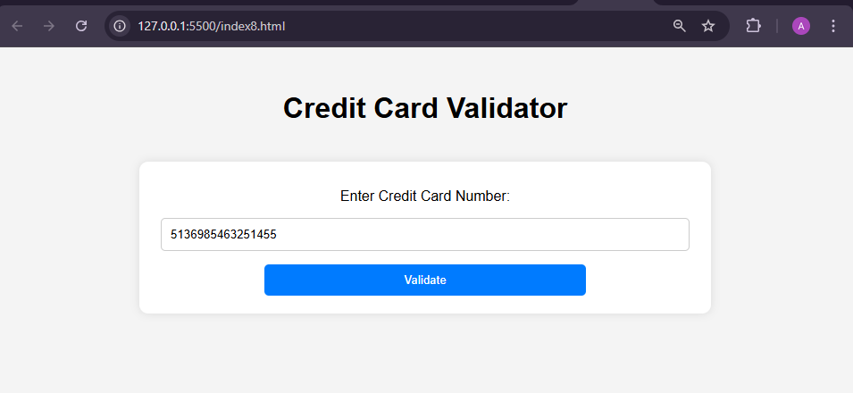

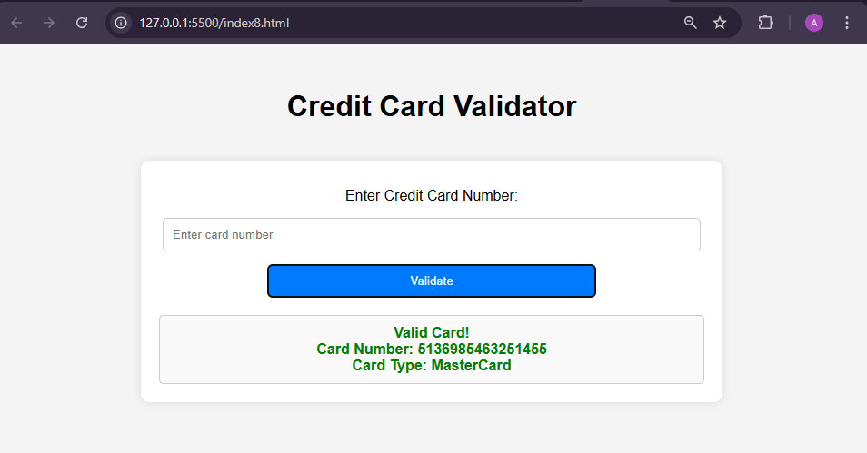

**9. A company wants to transmit data over the telephone, but it is concerned that its phones may be tapped. All of its data is transmitted as four-digit integers. It has asked you to write a program that will encrypt its data so that the data may be transmitted more securely. Your script should read a four-digit integer entered by the user in a prompt dialog and encrypt it as follows: Replace each digit by (the sum of that digit plus 7) modulus 10. Then swap the first digit with the third, and swap the second digit with the fourth. Then output HTML text that displays the encrypted integer.**

**Assuming the input is 1234, the output is:**



**CODE:**

<!DOCTYPE html>

<html lang="en">

<head>

<meta charset="UTF-8">

<meta name="viewport" content="width=device-width, initial-scale=1.0">

<title>Encrypt Four-Digit Integer</title>

<style>

body {

font-family: Arial, sans-serif;

margin: 0;

padding: 0;

display: flex;

flex-direction: column;

align-items: center;

height: 100vh;

background-color: #f4f4f4;

}

h1 {

text-align: center;

margin-top: 30px;

padding: 20px;

}

.container {

width: 600px;

padding: 20px;

background-color: #fff;

border-radius: 10px;

box-shadow: 0 0 10px rgba(0, 0, 0, 0.1);

}

label {

display: block;

margin-top: 10px;

}

input[type="number"] {

width: 95%;

padding: 10px;

margin-top: 15px;

border: 1px solid #ccc;

border-radius: 5px;

}

button {

width: 60%;

padding: 10px;

margin: 20px auto;

background-color: #007bff;

color: white;

border: none;

border-radius: 5px;

cursor: pointer;

display: block;

}

button:hover {

background-color: #0056b3;

}

.output {

margin-top: 20px;

background-color: #f9f9f9;

padding: 10px;

border-radius: 5px;

border: 1px solid #ccc;

display: none;

}

.output p {

margin: 0;

}

</style>

</head>

<body>

<h1>Encrypt Four-Digit Integer</h1>

<div class="container">

<label for="number">Enter a Four-Digit Number:</label>

<input type="number" id="number" placeholder="Enter a 4-digit number" min="1000" max="9999" required>

<button type="button" onclick="encryptNumber()">Encrypt</button>

<div class="output" id="output"></div>

</div>

<script>

function encryptNumber() {

const numberInput = document.getElementById('number');

const outputDiv = document.getElementById('output');

const number = numberInput.value;

if (!/^[0-9]{4}$/.test(number)) {

alert('Please enter a valid four-digit integer.');

return;

}

const digits = number.split('').map(digit => (parseInt(digit) + 7) % 10);

[digits[0], digits[2]] = [digits[2], digits[0]];

[digits[1], digits[3]] = [digits[3], digits[1]];

const encryptedNumber = digits.join('');

outputDiv.innerHTML = `

<p><strong>Original Number:</strong> ${number}</p>

<p><strong>Encrypted Number:</strong> ${encryptedNumber}</p>

`;

outputDiv.style.display = 'block';

numberInput.value = '';

}

</script>

</body>

</html>

**OUTPUT:**

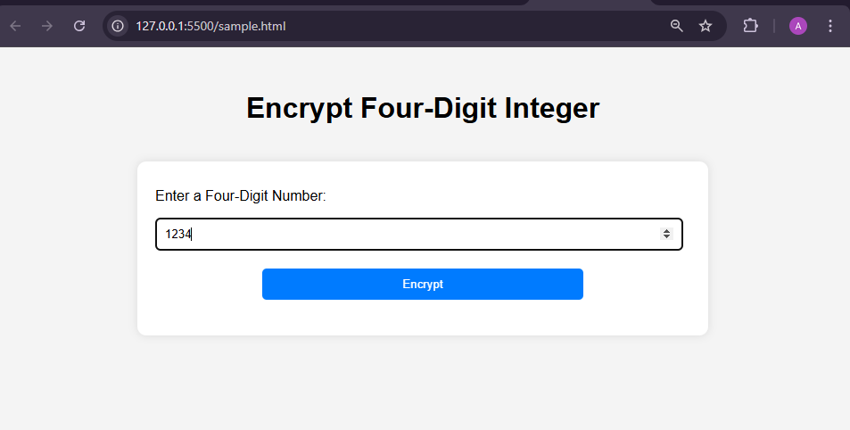

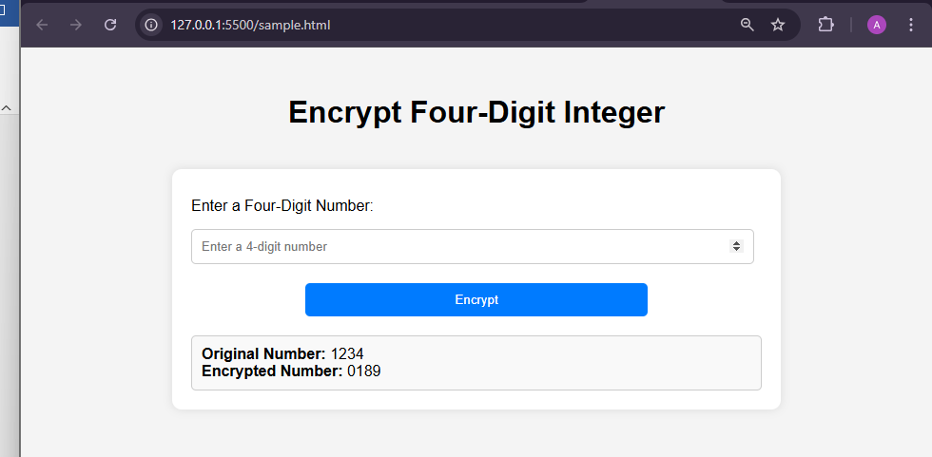

**10. BSNL has designed a grievance registration form in HTML with name of customer, address, telecom circle, email and grievance nature in a list box containing huge bills for limited mobile usage, roaming charges and frequent service disruption and a submit button.**

1. **Write a Javascript DOM event to be enabled when the user submits the form and display the complaint details in a tabular format.**
2. **If no grievance is selected, then invoke another DOM event to display “ No grievances”.**

**CODE:**

<!DOCTYPE html>

<html lang="en">

<head>

<meta charset="UTF-8">

<meta name="viewport" content="width=device-width, initial-scale=1.0">

<title>BSNL Grievance Registration</title>

<style>

body {

font-family: Arial, sans-serif;

margin: 0;

padding: 0;

display: flex;

flex-direction: column;

align-items: center;

height: 100vh;

background-color: #f4f4f4;

}

h1 {

text-align: center;

margin-top: 30px;

padding: 20px;

}

.container {

width: 800px;

padding: 20px;

background-color: #fff;

border-radius: 10px;

box-shadow: 0 0 10px rgba(0, 0, 0, 0.1);

}

label {

display: block;

margin-top: 10px;

}

input, select {

width: 95%;

padding: 10px;

margin-top: 15px;

border: 1px solid #ccc;

border-radius: 5px;

}

button {

width: 60%;

padding: 10px;

margin: 20px auto;

background-color: #007bff;

color: white;

border: none;

border-radius: 5px;

cursor: pointer;

display: block;

}

button:hover {

background-color: #0056b3;

}

.output {

margin-top: 20px;

background-color: #f9f9f9;

padding: 10px;

border-radius: 5px;

border: 1px solid #ccc;

display: none;

}

.output p {

margin: 0;

}

table {

width: 100%;

border-collapse: collapse;

margin-top: 20px;

}

table, th, td {

border: 1px solid #ccc;

}

th, td {

padding: 10px;

text-align: left;

}

</style>

</head>

<body>

<h1>BSNL Grievance Registration</h1>

<div class="container">

<label for="name">Name:</label>

<input type="text" id="name" placeholder="Enter your name" required>

<label for="address">Address:</label>

<input type="text" id="address" placeholder="Enter your address" required>

<label for="circle">Telecom Circle:</label>

<input type="text" id="circle" placeholder="Enter your telecom circle" required>

<label for="email">Email:</label>

<input type="email" id="email" placeholder="Enter your email" required>

<label for="grievance">Grievance Nature:</label>

<select id="grievance" required>

<option value="">Select a grievance</option>

<option value="huge_bills">Huge bills for limited mobile usage</option>

<option value="roaming_charges">Roaming charges</option>

<option value="service_disruption">Frequent service disruption</option>

</select>

<button type="button" onclick="submitForm()">Submit</button>

<div class="output" id="output"></div>

</div>

<script>

const complaints = [];

function submitForm() {

const name = document.getElementById('name').value;

const address = document.getElementById('address').value;

const circle = document.getElementById('circle').value;

const email = document.getElementById('email').value;

const grievance = document.getElementById('grievance').value;

const outputDiv = document.getElementById('output');

if (!name || !address || !circle || !email || !grievance) {

alert('Please fill in all fields.');

return;

}

if (!validateEmail(email)) {

alert('Please enter a valid email address.');

return;

}

if (!grievance) {

outputDiv.innerHTML = '<p>No grievances</p>';

outputDiv.style.display = 'block';

return;

}

const complaint = {

name,

address,

circle,

email,

grievance

};

complaints.unshift(complaint);

displayComplaints();

}

function validateEmail(email) {

const re = /^[^\s@]+@[^\s@]+\.[^\s@]+$/;

return re.test(email);

}

function displayComplaints() {

const outputDiv = document.getElementById('output');

let table = `

<table>

<tr>

<th>Name</th>

<th>Address</th>

<th>Telecom Circle</th>

<th>Email</th>

<th>Grievance Nature</th>

</tr>

`;

complaints.forEach(complaint => {

table += `

<tr>

<td>${complaint.name}</td>

<td>${complaint.address}</td>

<td>${complaint.circle}</td>

<td>${complaint.email}</td>

<td>${complaint.grievance}</td>

</tr>

`;

});

table += '</table>';

outputDiv.innerHTML = table;

outputDiv.style.display = 'block';

}

</script>

</body>

</html>

**OUTPUT:**

